Application Builder RAD Tools for Android & iOS

Shruti Vangari
The University of Akron
Sv47@zips.uakron.edu

Abstract

The presentation is a comparison of tools for Rapid Application Development (RAD) e.g. MobiForms 5.0, FormEntry, RADDroid and so on. These tools generate skeleton code that allow the development of mobile applications without the user of a traditional programming language i.e. Objective C, Java. The results of comparing the performance of these various tools for the two major platforms – iOS and Android are presented.

Introduction

Although traditional Integrated Development Environment (IDE) such as Net beans supports the development of Mobile applications, they provide lesser functionality and support compared to the Rapid Application Development (RAD) tools.

Categories of RAD tools

- Mobile Web - Uses JavaScript
- Visual Tool – Little or no access to Code
- App Generator – Apps for multi platforms
- Hybrid App – Embedded browser control
- Game Builder [1]

Table 1: Examples of RAD tools
DragonRAD | Appcelerator | BedRock
LiveCode | WidgetPad | Corona
MobiForms | PhoneGap | JUCE
FormEntry | MoSync | RHODES
RADDroid | Whoop | Xpower++
RhoMobile | Appmobi | Marmalade

There are exhaustive numbers of tools available that support the main mobile platforms:

- iOS
- Windows
- BlackBerry
- SymbianOS
- WebOS
The following scenario gives a typical mobile application scenario and the way an application pulls data.

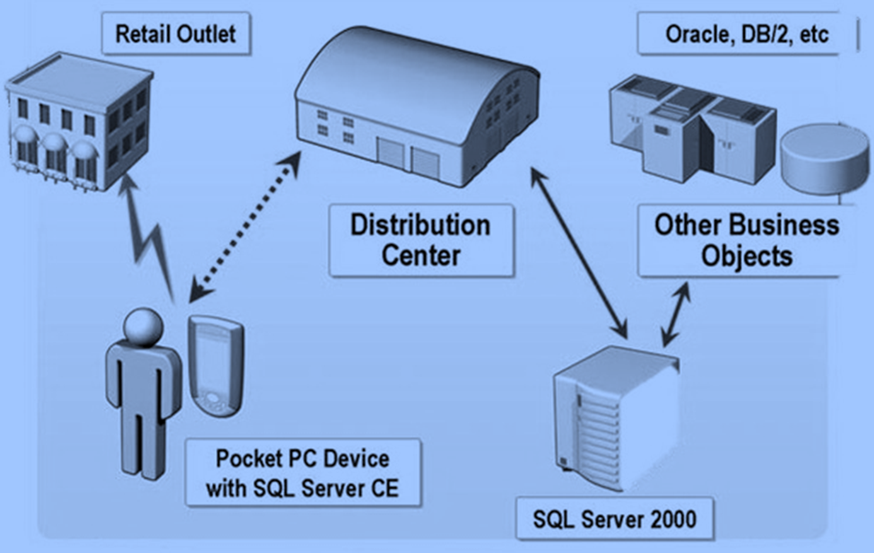
Fig 1: A typical mobile application scenario

Architecture of a RAD tool
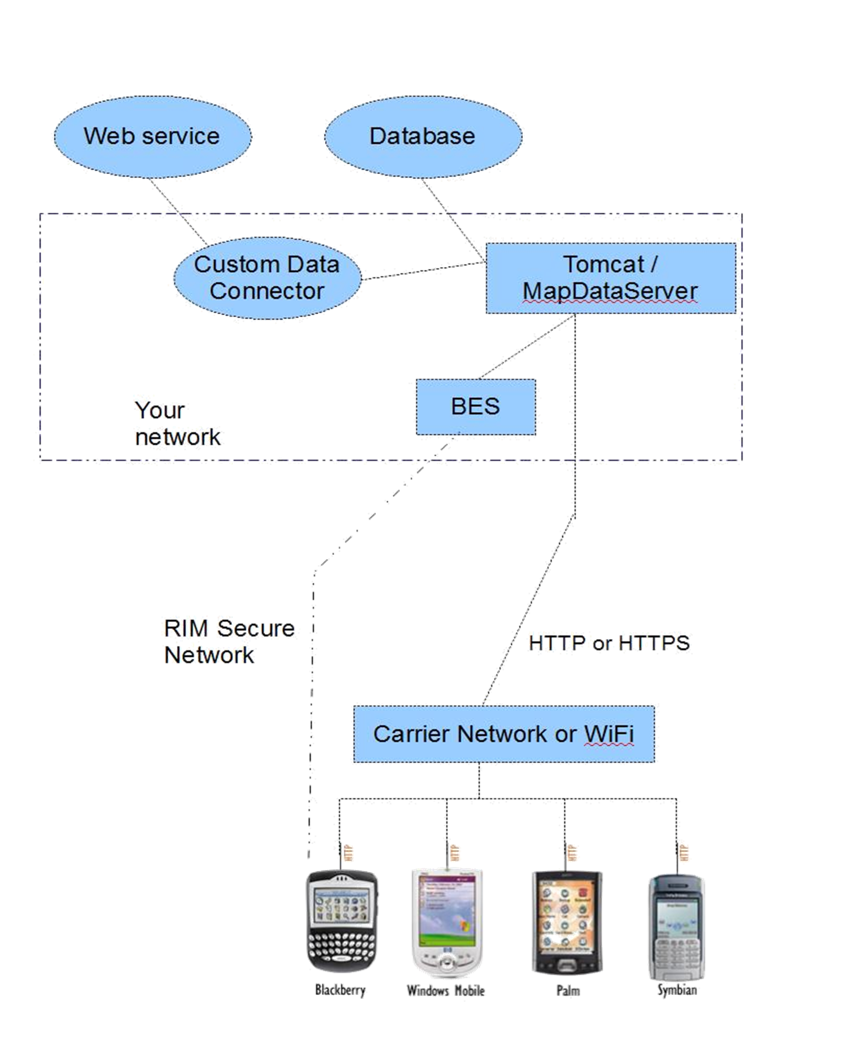
Fig 2: Architecture of the DragonRAD tool [5]

Comparison – Traditional programming language vs. RAD tool language

This is how a typical code looks like using a traditional programming language such as Objective C to write a simple “Hello World” program.

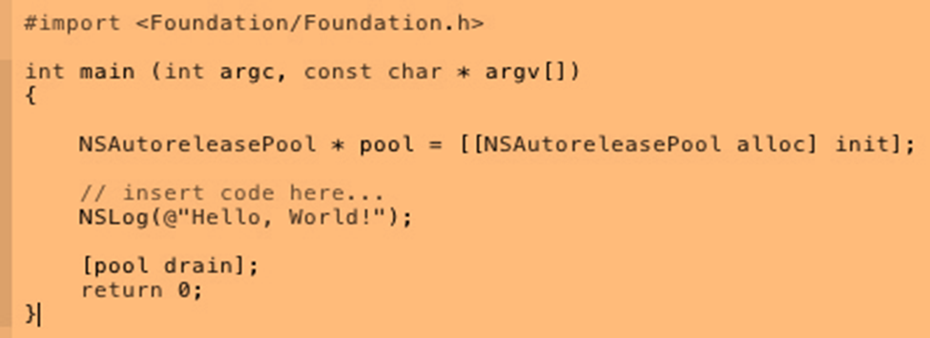
Fig 3: Printing “Hello World” in Objective C

A typical Hello World program in a RAD tool such as Live Code would like:

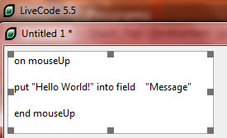

Fig 4: “Hello World” program in Live Code

A typical chess program with a GUI interface shown below would like:

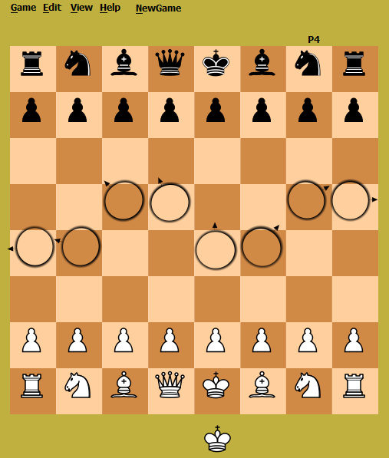

Fig 5: Chess program GUI

C# Desktop code would take around 5695 lines of code and 1.28MB space of storage whereas the same chess code in LiveCode took only around 154 lines of code with 10KB of storage space.

Summary of RAD tools

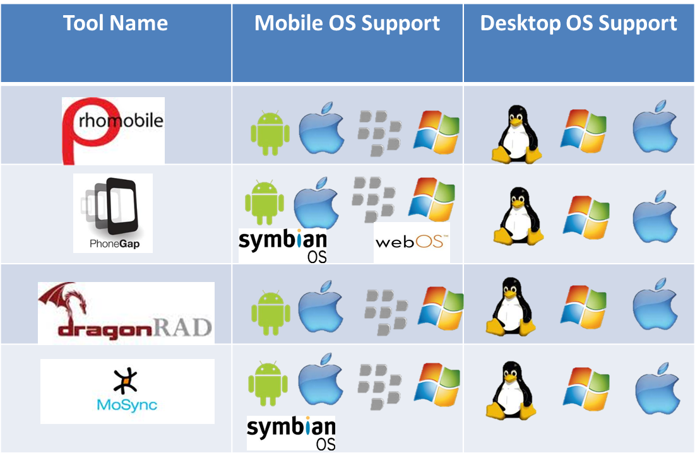

Fig 6: Comparison of 4 tools on a Desktop OS Support vs. on the Mobile OS Support [4]

Conclusions

The proposed benefits of RAD tools vs. OS tools: [2]

- Faster development time
- Productivity
- Error free code
- Enhanced readability
- Quality
- Any database connectivity
- Mini Tutorial
- Drag and Drop
- Cross Platform
- User need not learn traditional programming languages
- No-code hardware effects
The various usage scenarios for these apps tools:

- Health
- Information Management
- Micro Finance
- Education

References

[1] Amanquah, N.; Eporwei, O.T.; , "Rapid application development for mobile terminals," Adaptive Science & Technology, 2009. ICAST 2009. 2nd International

Conference on , vol., no., pp.410-417, 14-16 Jan. 2009. doi: 10.1109/ICASTECH.2009.5409691
http://ieeexplore.ieee.org/stamp/stamp.jsp?tp=&arnumber=5409691&isnumber=5409687

[2] Mobile Application Development Strategies: A White Paper outlining Technical / Business Considerations for managing enterprise mobile application development strategies.
Duane A. Nickull and Matt MacKenzie
http://uberity.com/whitepapers/Mobile-Application-Development-Strategy_FINAL.pdf

[3] Gavalas, D.; Economou, D.; , "Development Platforms for Mobile Applications: Status and Trends," Software, IEEE , vol.28, no.1, pp.77-86, Jan.-Feb. 2011. doi: 10.1109/MS.2010.155/
http://ieeexplore.ieee.org/stamp/stamp.jsp?tp=&arnumber=5654492&isnumber=5672507

[4] Indeerjeet ; Manuel Palmieri, “Comparison of cross-platform mobile development tools”
http://www.idt.mdh.se/kurser/ct3340/ht11/MINICONFERENCE/FinalPapers/ircse11_submission_16.pdf

[5] DragonRAD, What is DragonRad, March, 2011,
http://dragonrad.com/foswiki/bin/view/Help/Introduction

